|  |  |  |  |
| --- | --- | --- | --- |
|  | Bansilal Ramnath Agarwal Charitable Trust's  Vishwakarma Institute of Information Technology  **Department of**  **Artificial Intelligence and Data Science** | | |
| **Student Name:** **Siddhesh Dilip Khairnar** | | | |
| **Class:** **SY** | **Division:** **B** | | **Roll No:** **272028** |
| **Semester:** **4th** | | **Academic Year:** **2022-23** | |
| **Subject Name & Code:** **Software Engineering, ADUA22204** | | | |
| **Title of Assignment: Assignment No. 6: Derive the use cases based on the requirements from CPS and draw the State Diagram.** | | | |
| **Date of Performance:** **16-04-2023** | | **Date of Submission:** **25-04-2023** | |

**Aim:** **Derive the use cases based on the requirements from CPS and draw the State Diagram.**

**Software Requirement: Wondershare EdrawMax**

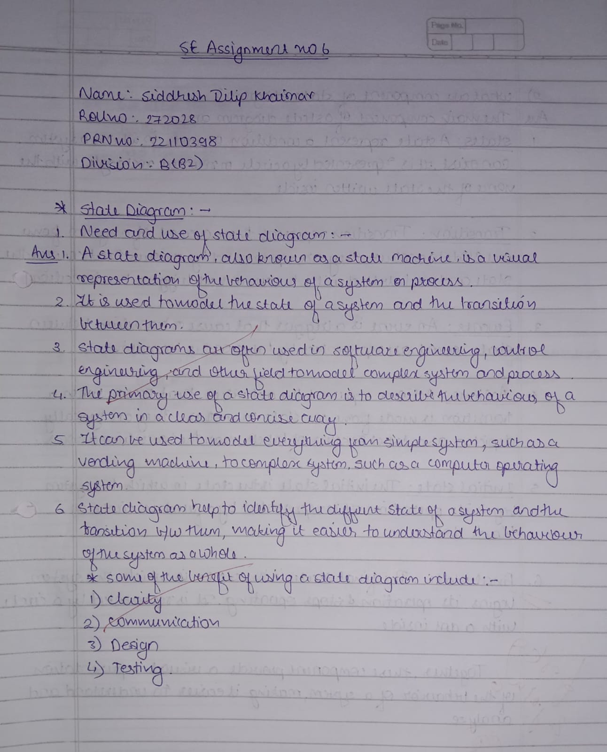

**Result of Experimentation:**

**CPS: Student finding Courses to learn different skills.**

* **STATE DIAGRAM**

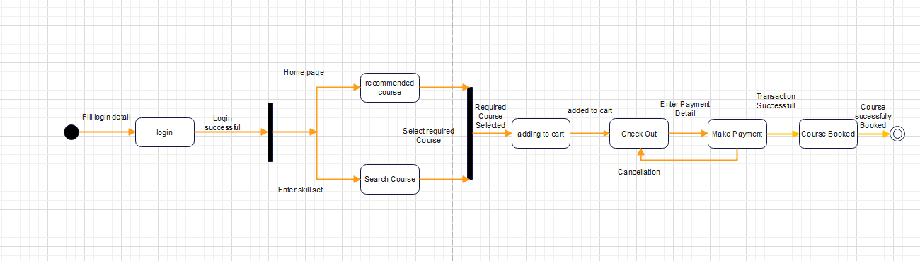

**Conclusion: Thus, we were able to understand the concept of State Diagram and we have implemented it through our given Customer Problem Statement (CPS).**